ASSIGNMENT -3

NAME: Suvikhyath Thirunahari
ROLL NUMBER:2503B05202 (M.TECH-Aiml)
Task:1

Problem-01:

A bit stream 1101011011 is transmitted using the standard CRC method. The generator polynomial is x 4 +x+1. What is the actual bit string transmitted?

CODE AND COMPILATION RESULTS:

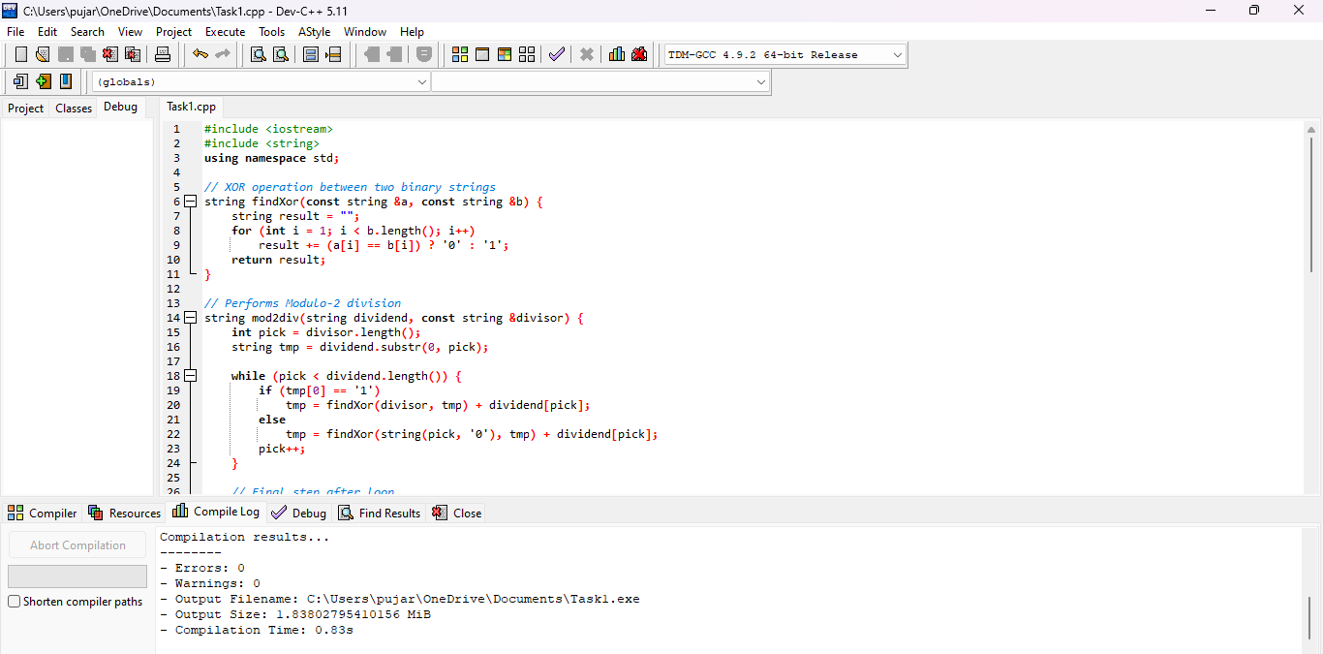

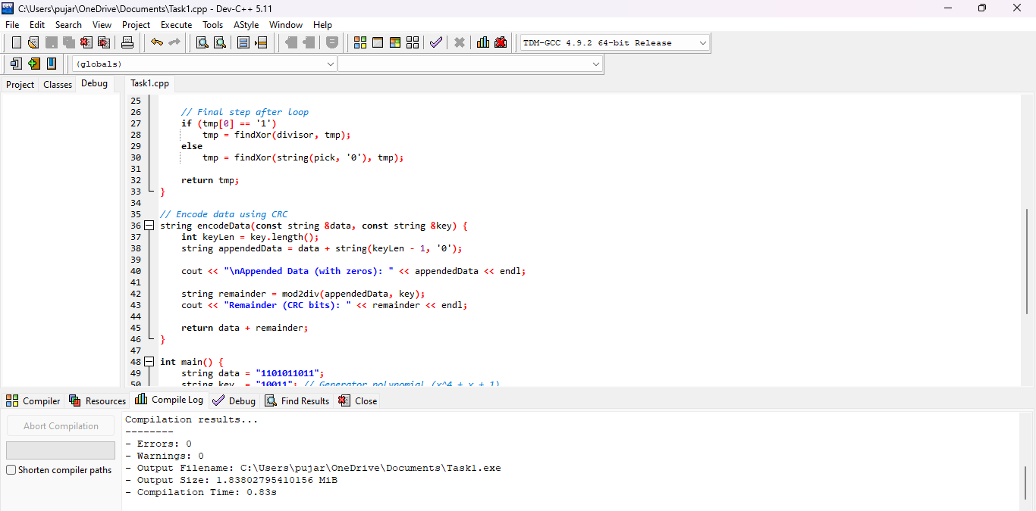

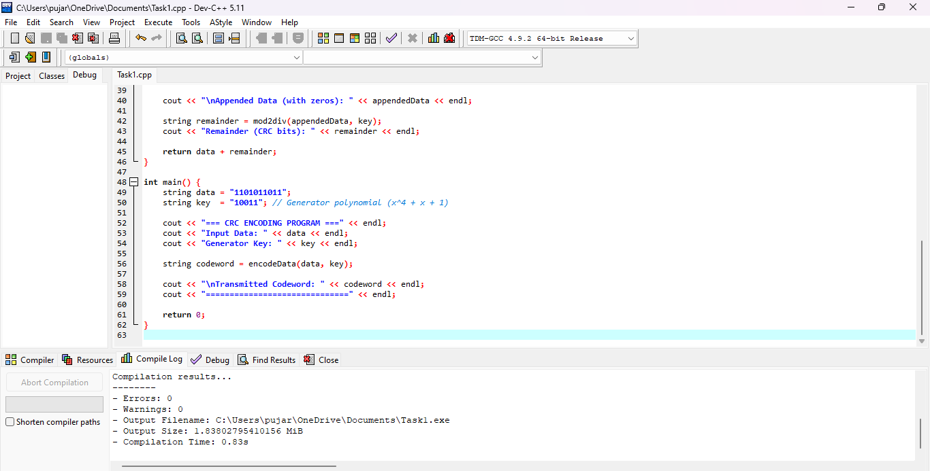

OUTPUT:
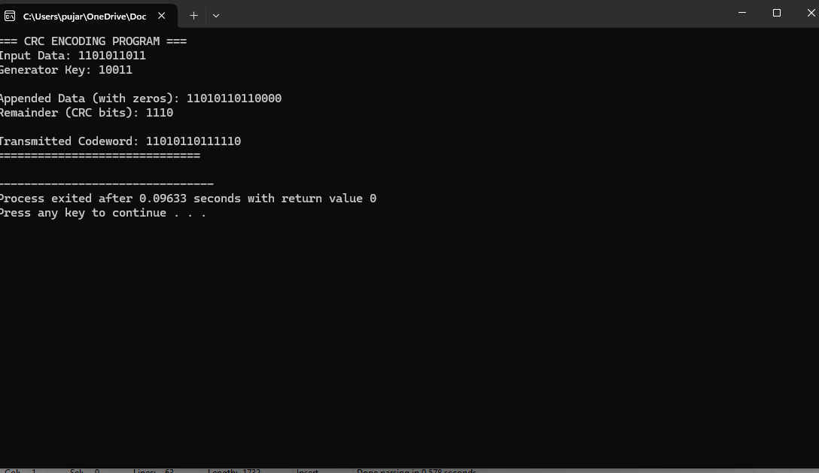

Task:2
Problem-02:
A bit stream 10011101 is transmitted using the standard CRC method. The generator polynomial x3+1.
1. What is the actual bit string transmitted?
2. Suppose the third bit from the left is inverted during transmission. How will receiver detect this error?

CODE AND COMPILATION RESULTS:

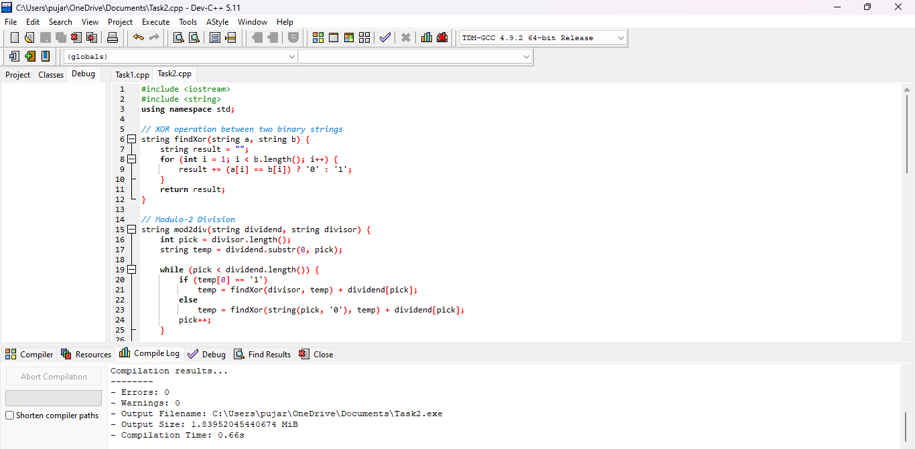

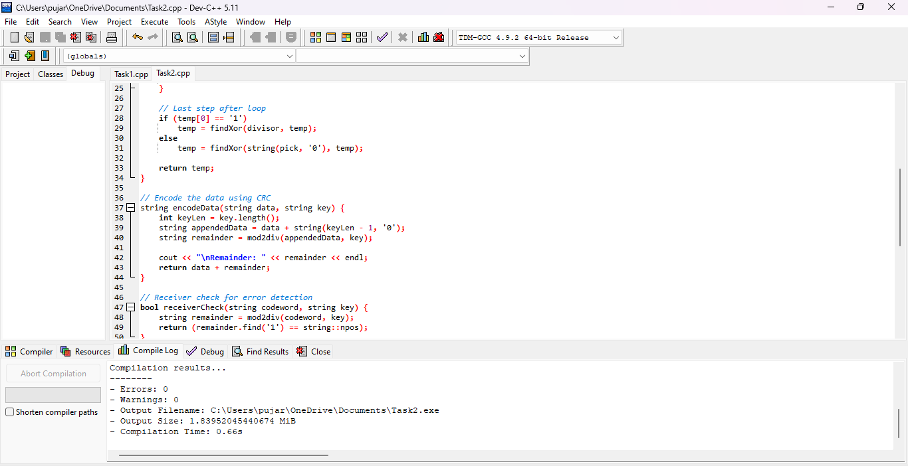
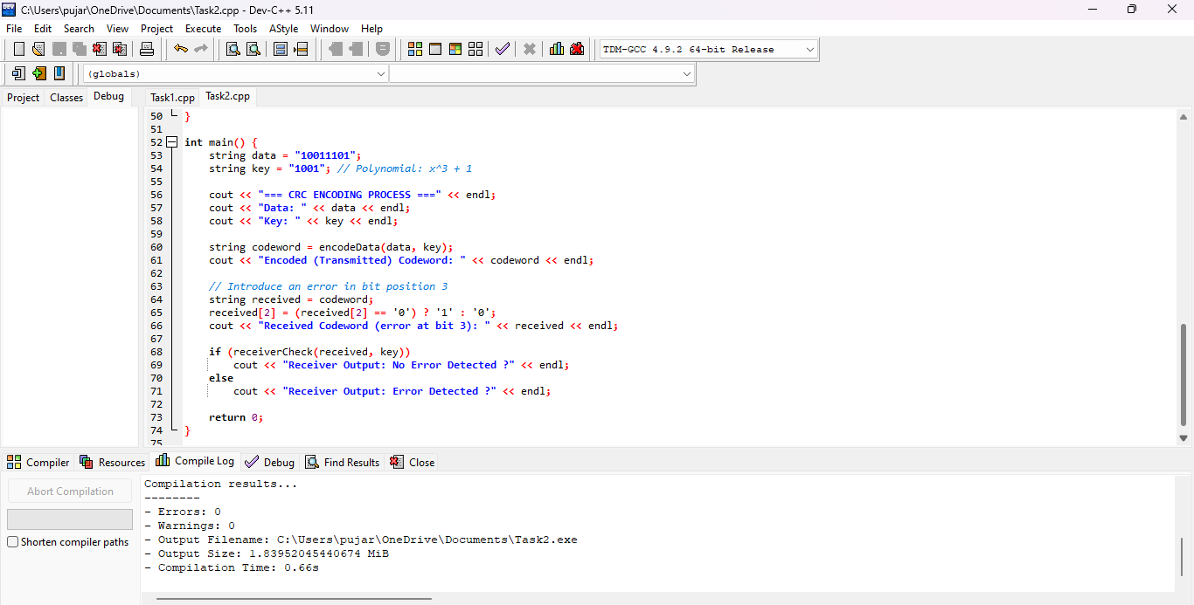

OUTPUT:

